3.40: a) The plane’s northward component of velocity relative to the air must be 80.0 km/h, so the heading must be 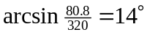 north of west. b) Using the angle found in part (a), 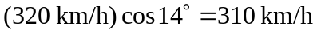. Equivalently, 

